15 inch Fanless Capacitive Touch Panel PC
ITPC-B150

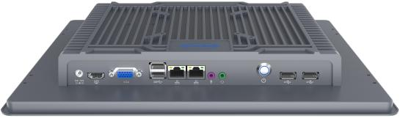
Features:
◇ All aluminum alloy structure, fanless design;
◇ Intel Celeron J1900,4th/6th Gen Core i5
◇ Adopt HD Industrial LCD screen and multi-point capacitive touch screen;
◇ Support1x MSATA slot，1x2.5inch SSD/HDD；
◇ 4xCOM Optional , COM2 Support RS232/485
◇ Support Desktop, Wall-mounted, Embedded, VESA standards installation;
◇ Full flat front panel, IP65 level protection；
◇ Applied OS:





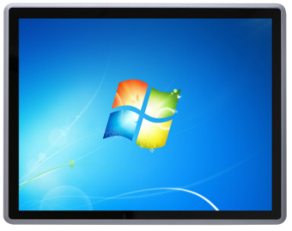

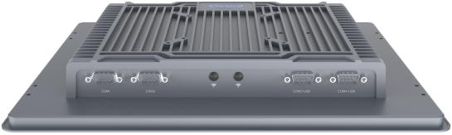

Specification
Model | ITPC-B150
Color | Gray
Material | Aluminum alloy chassis
Processor | Intel Celeron J1900 (Quad core quad threads,2.0Ghz,TDW:10W)
Processor | Intel Core i5 4200U (Dual core quad threads,1.6Ghz,Maximum Turbo 2.6 GHz)
Processor | Intel Core i5 6360U (Dual core quad threads,2.0 Ghz,Maximum Turbo 3.1 GHz)
Chipset | Intel CPU integrated chip
RAM | J1900：1*DDR3 1333/1600 SODIMM Memory Slot,Max. Support 8GB
RAM | i5-4200U:1*DDR3 1333/1600 SODIMM Memory Slot,Max. Support 8GB
RAM | i5-6360U：1*DDR3L 1600 SODIMM Memory Slot,Max. Support 16 GB
BIOS | AMI UEFI BIOS
Display Chip | J1900：Intel HD Graphics
Display Chip | i5-4200U：Intel HD Graphics 4400
Display Chip | i5-6360U：Intel HD Graphics 540
Display Port | 1xVGA，1xHDMI，1xLVDS；(Support synchronous and asynchronous dual display)
Storage | Support 1x MSATA slot，1x2.5inch SSD/HDD
Expansion Slot | Support 1x Mini PCIE slot（WIFI/4G Optional）
I/O | 1xPower Switch, 1xDC, 1xHDMI, 1xVGA, 2xUSB3.0, 2xUSB2.0
I/O | 2x RTL8111H 1000M Lan，1xMic，1xLine Out，2xCOM(COM2 RS232/RS485 Optional)
LCD | Size：15 inch TFT-LCD
LCD | Ratio: 4：3； Resolution: 1024* 768；
LCD | Brightness: 250 cd/㎡ Viewing Angle:70/70/65/60
Touch Screen | Multi-touch Capacitive touch screen,Lifetime: more than 50000 Thousand Times;
Speaker | Two 8-ohm 2-watt speaker
Input Voltage | DC 12V
Work Temp | 0℃ -- +50℃，Surface air flow
Work Humidity | 5% -- 95% non-condensing
Dimension | 349 * 274 * 45 mm
Installation size | Embedded Size：339 * 264 mm; Wall-Mount Size：75 * 75 mm/100 * 100 mm
Weight | 3.19 kg
Application | Industrial automation,medical,logistics and transportation,warehousing,electronic education and other fields

ITPC-B150 Drawing

Accessories List
Name | Quantity | Specification
Power Adapter | 1 | 12V 5A
Power Cord | 1 | Any Plug Optional  (China, US, EU, UK etc.)
Embedded Mounting Clip | 4 | For Standard Embedded Installation
Desktop, wall-mounted, Stereo stand | 1 | Optional Accessories
Order information
Configuration 1 | ITPC-B150 | Intel Celeron J1900 | Standard Port  (J1900 1xUSB3.0,3xUSB2.0)
Configuration 2 | ITPC-B150 | Intel Core i5-4200U | Standard Port
Configuration 3 | ITPC-B150 | Intel Core i5-6360U | Standard Port（2xIntel I211 Lan port)
