17 inch Fanless Resistance Touch Panel PC

ITPC-A600

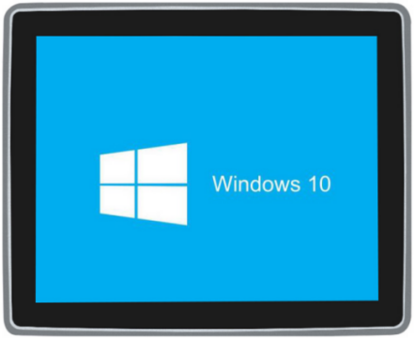

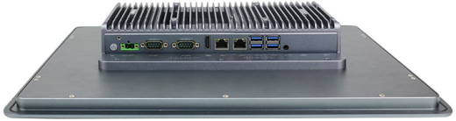
Features:
◇ Die cast aluminum alloy moluding,fanless design;
◇ Onboard Intel Whiskey Lake U series processor;
◇Support 9V ～ 36V wide voltage Input, and TPM2.0 security encryption;
◇ Support TPM2.0,Windows 11
◇ Support 2*RS232/422/485 COM,6*COM Optional;
◇ Support 2*Intel lans,4*Intel lans Optional;
◇ IP65 full flat front panel;
◇ Applied OS:


Specification
Model | ITPC-A600
Color | Titanium gray (Color can be customized)
Material | Aluminum alloy chassis
Processor | Onboard Intel Celeron 4205U(Dual core dual threads,1.8Ghz,2MB Cache);
Processor | Onboard Intel Core i5-8265U(Quad core eight threads,1.6Ghz,Max turbo 3.9Ghz,6MB Cache);
Processor | Onboard Intel Core i7-8565U(Quad core eight threads,1.8Ghz,Max turbo 4.6Ghz,8MB Cache);
RAM | Support 1*DDR4 2133/2400 SODIMM Memory Slot,Max. Support 32GB
BIOS | AMI EFI BIOS
Display Chip | Integrated Intel UHD Graphics
Display Port | 1*HDMI,1*LVDS(Support synchronous and asynchronous dual display)
Storage | Onboard 1*M.2 2280 slot(SATA Protocol),1*2.5” HDD,Support RAID 0/1
Expansion Slot | Support 1*Mini PCIE slot(Support WIFI/Bluetooth/3G/4G Optional,embedded SIM slot)
I/O | 1*HDMI,2*COM(COM1&COM2 support RS232/RS422/RS485,6*COM Optional),1*Power Switch
I/O | 1*2Pin power supply phoenix connector,1*Audio (Support Mic and Speaker at the same time),4*USB3.0,2*Intel 1000M LAN（4*LAN Optional）
Other Function | TPM2.0 security encryption、Auto power on when there is electricity、Timing boot、Wake on LAN、PXE boot、Watchdog（0～255 level）(Standard version doesn’t set these function)
Expansion Function | GPIO（8 Input 8 Output）、2*LAN、4*COM、2*USB2.0 （Standard version doesn’t include these ports）
LCD | Size：17 inch TFT-LCD;Brightness:250 cd/m^{2;}Viewing Angle:Full Angle
LCD | Ratio:4:3;Resolution:1280 * 1024;
Touch Screen | Industrial grade multi-touch resistance touch screen,Life Time: more than 50000 Thousand Times;
Speaker | Two 8-ohm 2-watt speaker
Input Voltage | DC 9V ～ 36V wide voltage Input，support positive pole and negative electrode connect reversely protection;
Work Temp | 0℃ ～ +50℃（Commercial），-20℃ ～ +60℃（Industrial SSD），Surface air flow
Work Humidity | 5% ～ 95% non-condensing
Dimension | 408.5 * 346*61 mm
Embedded Installation | 389 * 321mm
Weight | 4.7 kg
Application | Industrial Automation,Medical,Logistics Transportation, Warehousing, Machine Vision, etc
ITPC-A600 Drawing

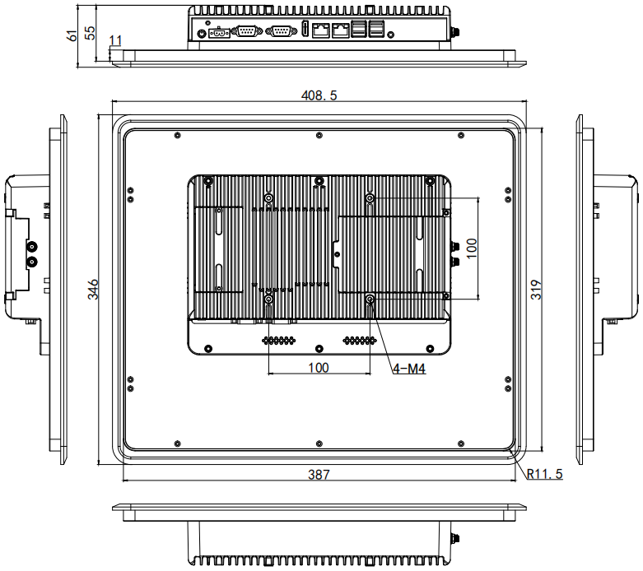

Accessories List
Name | Quantity | Specification
Power Adapter | 1 | 12V5A
Power Cord | 1 | Any Plug Optional  (China, US, EU, UK etc.)
Embedded Mounting Clip | 4 | For Standard Embedded Installation

Order information
Configuration 1 | ITPC-A116 | Intel Celeron 4205U | Standard Port
Configuration 2 | ITPC-A116 | Intel Core i5-8265U | Standard Port
Configuration 3 | ITPC-A116 | Intel Core i7-8565U | Standard Port
Remark：There is conflict between the expansion function ports’ fixed position and the standard version ports’ fixed position, so if you need some expansion function ports, please check with us first, thanks.

